CTL DECISION SHEET (DSH)

Standard(s)- (incl. year)  IEC 60950-1:2005/A1 | Subclause(s):  1.5.9.4 | No. | Year
Standard(s)- (incl. year)  IEC 60950-1:2005/A1 | Subclause(s):  1.5.9.4 | DSH  0794 | 2011
Category: OFF | Subclause(s):  1.5.9.4 | Developed by:ETF 2
Subject:  Requirements of subclause  1.5.9.4 of IEC  60950-1:2005 and IEC  60950-1:2005/A1 for  combinations of varistors  (VDR) and gas discharge  tubes (GDT) | Key words:  - Varistor  - Gas discharge tube  - Earthing | Approved at the 2011 CTL Plenary Meeting)
Question:
Is it relevant in series connections of VDR+GDT, which component is connected to PE?
See circuit diagram below.

Decision:
The order of VDR and GDT is driven by its specific application, and for safety reasons it
cannot be generally said, which component of the two must be connected to PE. The
PE connection shall be made in accordance with sub-clause 1.5.9.4 and the
corresponding component application requirements of the manufacturer shall be
followed.

Explanatory Notes:

a) Two examples with different components connected to PE:
- Option A with the GDT connected to PE
- Option B with the VDRs connected to PE
In both options, the combination of VDR+GDT is connected to PE.

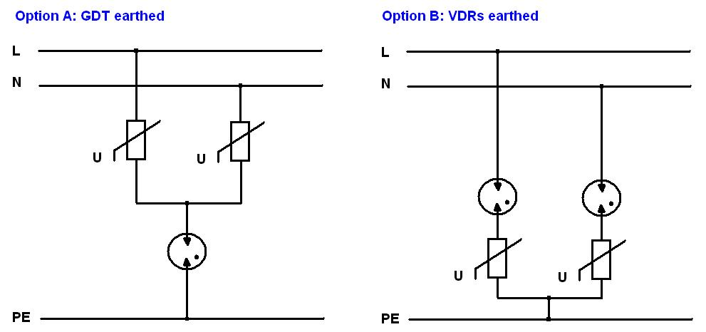

b) Other requirements of sub-clause 1.5.9 apply, in particular 1.5.9.1 and 1.5.9.2.

Additional information is given in the 108/441/INF document. The 108/441/INF
document is published on the CTL web site: http://www.cbscheme.org/ctl/TCsheets/
108_441e_INF.pdf.

